**Router 0 CLI:**

Router>en

Router#conf t

Enter configuration commands, one per line. End with CNTL/Z.

Router(config)#int f0/0

Router(config-if)#ip address 192.168.1.1 255.255.255.0

Router(config-if)#ip dhcp pool router1

Router(dhcp-config)#network 192.168.1.1

% Incomplete command.

Router(dhcp-config)#network 192.168.1.1 255.255.255.0

Router(dhcp-config)#default-router 192.168.1.1

Router(dhcp-config)#dns-server 192.168.10.100

Router(dhcp-config)#ex

Router(config)#int se2/0

Router(config-if)#ip address 192.168.3.1 255.255.255.0

Router(config-if)#no shutdown

%LINK-5-CHANGED: Interface Serial2/0, changed state to down

Router(config-if)#

Router(config-if)#exit

Router(config)#interface FastEthernet0/0

Router(config-if)#no shutdown

Router(config-if)#

%LINK-5-CHANGED: Interface FastEthernet0/0, changed state to up

%LINEPROTO-5-UPDOWN: Line protocol on Interface FastEthernet0/0, changed state to up

%DHCPD-4-PING_CONFLICT: DHCP address conflict: server pinged 192.168.1.1.

%LINK-5-CHANGED: Interface Serial2/0, changed state to up

%LINEPROTO-5-UPDOWN: Line protocol on Interface Serial2/0, changed state to up

Router(config-if)#router eigrp 1

Router(config-router)#network 192.168.1.0

Router(config-router)#network 192.168.3.0

Router(config-router)#

%DUAL-5-NBRCHANGE: IP-EIGRP 1: Neighbor 192.168.3.2 (Serial2/0) is up: new adjacency

**Router1 CLI:**

Router>en

Router#conf t

Enter configuration commands, one per line. End with CNTL/Z.

Router(config)#int f0/0

Router(config-if)#ip address 192.168.2.1 255.255.255.0

Router(config-if)#ip dhcp pool router2

Router(dhcp-config)#network 192.168.2.1 255.255.255.0

Router(dhcp-config)#default-router 192.168.2.1

Router(dhcp-config)#dns-server 192.168.10.100

Router(dhcp-config)#ex

Router(config)#

Router(config)#interface FastEthernet0/0

Router(config-if)#no shutdown

Router(config-if)#

%LINK-5-CHANGED: Interface FastEthernet0/0, changed state to up

%LINEPROTO-5-UPDOWN: Line protocol on Interface FastEthernet0/0, changed state to up

%DHCPD-4-PING_CONFLICT: DHCP address conflict: server pinged 192.168.2.1.

Router(config-if)#exit

Router(config)#interface Serial2/0

Router(config-if)#clock rate 148000

This command applies only to DCE interfaces

Router(config-if)#no shutdown

Router(config-if)#

%LINK-5-CHANGED: Interface Serial2/0, changed state to up

ip address 192.168.3.2 255.255.255.0

Router(config-if)#

%LINEPROTO-5-UPDOWN: Line protocol on Interface Serial2/0, changed state to up

Router(config-if)#router eigrp 1

Router(config-router)#network 192.168.2.0

Router(config-router)#network 192.168.3.0

Router(config-router)#

%DUAL-5-NBRCHANGE: IP-EIGRP 1: Neighbor 192.168.3.1 (Serial2/0) is up: new adjacency

Router(config-router)#ex

Router(config)#int se3/0

Router(config-if)#ip address 192.168.4.1 255.255.255.0

Router(config-if)#no shutdown

%LINK-5-CHANGED: Interface Serial3/0, changed state to down

Router(config-if)#

%LINK-5-CHANGED: Interface Serial3/0, changed state to up

%LINEPROTO-5-UPDOWN: Line protocol on Interface Serial3/0, changed state to up

Router(config-if)#router eigrp 1

Router(config-router)#network 192.168.4.0

Router(config-router)#

%DUAL-5-NBRCHANGE: IP-EIGRP 1: Neighbor 192.168.4.2 (Serial3/0) is up: new adjacency

Router(config-router)#router eigrp 1

Router(config-router)#network 192.168.10.100

Router(config-router)#network 192.168.10.0

Router(config-router)#

**Router2 CLI:**

Router>en

Router#conf t

Enter configuration commands, one per line. End with CNTL/Z.

Router(config)#int f0/0

Router(config-if)#ex

Router(config)#int se2/0

Router(config-if)#ip address 192.168.4.2 255.255.255.0

Router(config-if)#no shutdown

Router(config-if)#

%LINK-5-CHANGED: Interface Serial2/0, changed state to up

Router(config-if)#router eigrp 1

Router(config-router)#

%LINEPROTO-5-UPDOWN: Line protocol on Interface Serial2/0, changed state to up

Router(config-router)#network 192.168.3.0

Router(config-router)#network 192.168.4.0

Router(config-router)#

%DUAL-5-NBRCHANGE: IP-EIGRP 1: Neighbor 192.168.4.1 (Serial2/0) is up: new adjacency

Router(config-router)#exit

Router(config)#interface FastEthernet1/0

Router(config-if)#ip address 192.168.10.100 255.255.255.0

Router(config-if)#no shutdown

Router(config-if)#

%LINK-5-CHANGED: Interface FastEthernet1/0, changed state to up

%LINEPROTO-5-UPDOWN: Line protocol on Interface FastEthernet1/0, changed state to up

Router(config-if)#int f1/0

Router(config-if)#ip dhcp pool router3

Router(dhcp-config)#default-router 192.168.10.1

Router(dhcp-config)#%IP-4-DUPADDR: Duplicate address 192.168.10.100 on FastEthernet1/0, sourced by 0060.5CCC.66CC

Router(dhcp-config)#router eigrp 1

Router(config-router)#network 192.168.10.0

Router(config-router)#network 192.168.4.0

Router(config-router)#network 192.168.10.100

Router(config-router)#%IP-4-DUPADDR: Duplicate address 192.168.10.100 on FastEthernet1/0, sourced by 0060.5CCC.66CC

Router(config-router)#exit

Router(config)#interface FastEthernet1/0

Router(config-if)#

Router(config-if)#exit

Router(config)#interface FastEthernet0/0

Router(config-if)#

Router(config-if)#exit

Router(config)#interface FastEthernet1/0

Router(config-if)#

Router(config-if)#exit

Router(config)#interface FastEthernet1/0

Router(config-if)#ip dhcp pool router3

Router(dhcp-config)#network 192.168.10.1

% Incomplete command.

Router(dhcp-config)#network 192.168.10.1 255.255.255.0

Router(dhcp-config)#default-router 192.168.10.1

Router(dhcp-config)#dns-server 192.168.10.100

Router(dhcp-config)#%IP-4-DUPADDR: Duplicate address 192.168.10.100 on FastEthernet1/0, sourced by 0060.5CCC.66CC

Router(dhcp-config)#exit

Router(config)#interface FastEthernet0/0

Router(config-if)#

Router(config-if)#exit

Router(config)#interface FastEthernet1/0

Router(config-if)#ip address 192.168.10.1 255.255.255.0

Router(config-if)#ex

Router(config)#int f0/0

Router(config-if)#ip address 192.168.5.1 255.255.255.0

Router(config-if)#

Router(config-if)#exit

Router(config)#interface FastEthernet0/0

Router(config-if)#no shutdown

Router(config-if)#

%LINK-5-CHANGED: Interface FastEthernet0/0, changed state to up

%LINEPROTO-5-UPDOWN: Line protocol on Interface FastEthernet0/0, changed state to up

Router(config-if)#router eigrp 1

Router(config-router)#network 192.168.5.0

Router(config-router)#

%DUAL-5-NBRCHANGE: IP-EIGRP 1: Neighbor 192.168.5.2 (FastEthernet0/0) is up: new adjacency

**Router3 CLI:**

Router>en

Router#config t

Enter configuration commands, one per line. End with CNTL/Z.

Router(config)#int f0/0

Router(config-if)#ip address 192.168.5.2 255.255.255.0

Router(config-if)#no shutdown

Router(config-if)#

%LINK-5-CHANGED: Interface FastEthernet0/0, changed state to up

%LINEPROTO-5-UPDOWN: Line protocol on Interface FastEthernet0/0, changed state to up

Router(config-if)#router eigrp 1

Router(config-router)#network 192.168.5.0

Router(config-router)#

%DUAL-5-NBRCHANGE: IP-EIGRP 1: Neighbor 192.168.5.1 (FastEthernet0/0) is up: new adjacency

Router(config-router)#ex

Router(config)#int f0/1

Router(config-if)#ip address 192.168.6.1 255.255.255.0

Router(config-if)#no shutdown

Router(config-if)#

%LINK-5-CHANGED: Interface FastEthernet0/1, changed state to up

%LINEPROTO-5-UPDOWN: Line protocol on Interface FastEthernet0/1, changed state to up

Router(config-if)#ip dhcp pool router4

Router(dhcp-config)#network 192.168.6.1 255.255.255.0

Router(dhcp-config)#default-router 192.168.6.1

Router(dhcp-config)#dns-server 192.168.10.100

Router(dhcp-config)#ex

Router(config)#ip dhcp pool voice

Router(dhcp-config)#ip dhcp pool router4

Router(dhcp-config)#option 150 ip 192.168.6.1

Router(dhcp-config)#ex

Router(config)#telephony-service

Router(config-telephony)#max-dn 3

Router(config-telephony)#ephones 3

^

% Invalid input detected at '^' marker.

Router(config-telephony)#max-ephones 3

Router(config-telephony)#ip source-address 192.168.6.1 port 2000

Router(config-telephony)#auto assign 1 to 3

Router(config-telephony)#ephone-dn 1

Router(config-ephone-dn)#%LINK-3-UPDOWN: Interface ephone_dsp DN 1.1, changed state to up

Router(config-ephone-dn)#number 12345

Router(config-ephone-dn)#ex

Router(config)#ephone-dn 2

Router(config-ephone-dn)#%LINK-3-UPDOWN: Interface ephone_dsp DN 2.1, changed state to up

Router(config-ephone-dn)#number 123

Router(config-ephone-dn)#

%LINEPROTO-5-UPDOWN: Line protocol on Interface FastEthernet0/1, changed state to down

%LINEPROTO-5-UPDOWN: Line protocol on Interface FastEthernet0/1, changed state to up

Router(config-ephone-dn)#ephone-dn 3

Router(config-ephone-dn)#%LINK-3-UPDOWN: Interface ephone_dsp DN 3.1, changed state to up

Router(config-ephone-dn)#number 12

Router(config-ephone-dn)#ex

Router(config)#telephony-services

^

% Invalid input detected at '^' marker.

Router(config)#telephony-service

Router(config-telephony)#ip source-address 192.168.6.1 port 2000

Router(config-telephony)#auto assign 1 to 3

Router(config-telephony)#

%DUAL-5-NBRCHANGE: IP-EIGRP 1: Neighbor 192.168.5.1 (FastEthernet0/0) is down: holding time expired

%DUAL-5-NBRCHANGE: IP-EIGRP 1: Neighbor 192.168.5.1 (FastEthernet0/0) is up: new adjacency

%DUAL-5-NBRCHANGE: IP-EIGRP 1: Neighbor 192.168.5.1 (FastEthernet0/0) is down: Interface Goodbye received

%DUAL-5-NBRCHANGE: IP-EIGRP 1: Neighbor 192.168.5.1 (FastEthernet0/0) is up: new adjacency

%DHCPD-4-PING_CONFLICT: DHCP address conflict: server pinged 192.168.6.1.

%DHCPD-4-PING_CONFLICT: DHCP address conflict: server pinged 192.168.6.1.

Router(config-telephony)#ex

Router(config)#router eigrp 1

Router(config-router)#network 192.168.5.0

Router(config-router)#network 192.168.6.0

Router(config-router)#network 192.168.1.0

Router(config-router)#

Router>en

Router#config t

Enter configuration commands, one per line. End with CNTL/Z.

Router(config)#te

Router(config)#telephony-service

Router(config-telephony)#max-dn 5

Router(config-telephony)#

**Server IP Address:** 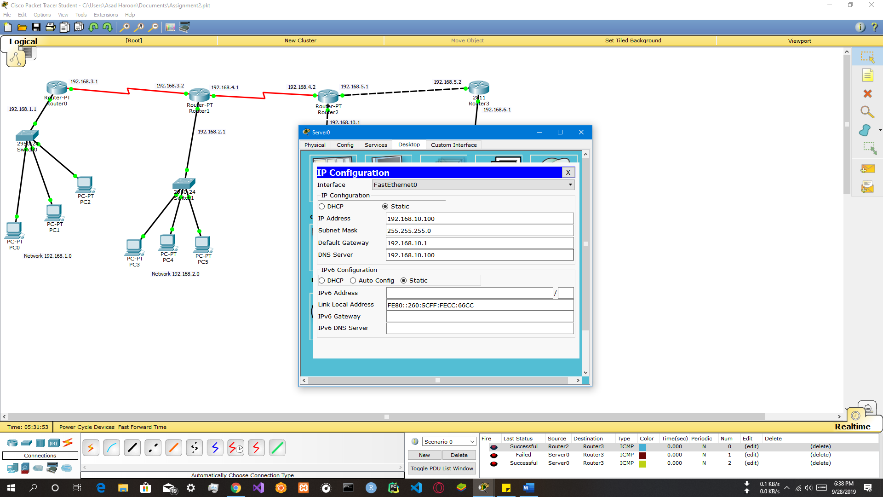

**Network ScreenShot:**

